Wildfire: Email and Social Media Toolkit

Brokers and Agents: Customize the copy below to send emails directly to your clients. You can also add your own messages or notes to the templates before sending. Please do not modify the hyperlinks provided on each template.

Email Copy to Insureds

Preparation Phase (Before Wildfires Begin) – copy and paste the below into a new email on your platform of choice.

Subject:
Wildfire Preparedness: CNA Resources to Protect Your Business

Dear [Client Name],

Although the possibility of wildfires is an inevitable part of live where we live, there are clear steps your business can take to be prepared.
CNA’s Wildfire Resource Center has clear, actionable insight and plans to help protect your people, property and operations in the event of a wildfire.

Visit CNA's Wildfire Resource Center to learn more.

If you’d like help reviewing your current preparedness plan or have questions about your
coverage, please don’t hesitate to reach out. I’m here to support you every step of the way.

Stay safe and prepared,

[Your Name]
[Your Contact Information]

Respond Phase (During Wildfire) - copy and paste the below into a new email on your platform of choice.

Subject:
How to Protect Your Business During this Wildfire: Help from CNA

Dear [Client Name],

I hope you and your team are safe. As wildfires continue to impact our area, I want to ensure you have the guidance and support you need to protect your people, property and operations.

CNA has compiled practical, real-time resources to help you prepare and respond. Visit CNA's Wildfire Resource Center to learn more.

Key Steps to Protect Your Business
- Monitor real-time updates and official guidance
- Clear areas around windows and entry points
- Close all doors, windows and vents
- Pack vital records
- Move vehicles away from structures
It is important to follow orders from local authorities regarding evacuations. If time and conditions allow you to do so safely, secure your facility by taking these precautionary steps before departing:
- Turn off machinery and equipment
- Close main gas lines
- Shut outdoor fuel valves
- Ensure fire sprinkler valves remain wide open
Your safety is the top priority. Please don’t hesitate to reach out at any time before, during and after the wildfire in your area. I’m here to support you every step of the way.

Need to Report a Claim?

CNA’s Catastrophe Operations Center is fully staffed and ready to assist:

General Claims:
• Phone: 877-CNA-ASAP (877-262-2727), Option 2
• Fax: 800-953-7389
• Email: lossreport@cnaasap.com

Small Business Claims:
• Phone: 833-FNOL-CNA (833-366-5262)
• Fax: 877-291-2019
• Email: ReportClaim@FNOLCNA.com

Stay safe and prepared,
[Your Name]
[Your Contact Information]

Recovery Phase (After Wildfire) - copy and paste the below into a new email on your platform of choice.

Subject:
Recovering: CNA Wildfire Resources for Your Business

Dear [Client Name],

I hope your team is safe following the recent wildfires. As you look to return to normal operations, there are several important steps to take now to ensure your property is structurally secure and free of hazards.

Key Steps for Safe Recovery
- Document all damage with photos and video before cleaning up
- Establish temporary operations or remote workspaces
- Hire professionals to check utilities and restore electrical power slowly
- Clean ventilation and utility lines to replace ruined filters and flush stagnant systems
- Follow manufacturer instructions and test all safety switches before restarting machinery
- Verify that all building certificates and official regulatory inspections are up to date
CNA’s Wildfire Resource Center has more recovery tips and resources to assist you through this time. Whether your damage is minor or major, I’m here to support you every step of the way.

Need to Report a Claim?

CNA’s Catastrophe Operations Center is fully staffed and ready to assist:

General Claims:
• Phone: 877-CNA-ASAP (877-262-2727), Option 2
• Fax: 800-953-7389
• Email: lossreport@cnaasap.com

Small Business Claims:
• Phone: 833-FNOL-CNA (833-366-5262)
• Fax: 877-291-2019
• Email: ReportClaim@FNOLCNA.com

Stay safe and prepared,
[Your Name]
[Your Contact Information]

Social Media Copy and Images

Copy and paste the below copy into a new post on your social media platform of choice. Pair with the suggested image by right-clicking, downloading, then uploading the image to the new post. Please do not modify the highlighted hyperlinks given on each post captions. Links will shorten automatically when posted onto LinkedIn.

- Preparing for a Wildfire- Version 1

Caption:
For today's businesses, wildlife preparedness is a year-round necessity. A clear plan helps protect your property, operations and the people who keep your business running.

CNA provides actionable insights and guidance to help your business prepare.

Act now to strengthen your protection.
LINK: https://www.cna.com/wildfire-resource-center?utm_source=toolkit&utm_medium=social&utm_campaign=nap-wildfire-2026&utm_content=prepare-post-1

Questions? Reach out anytime.

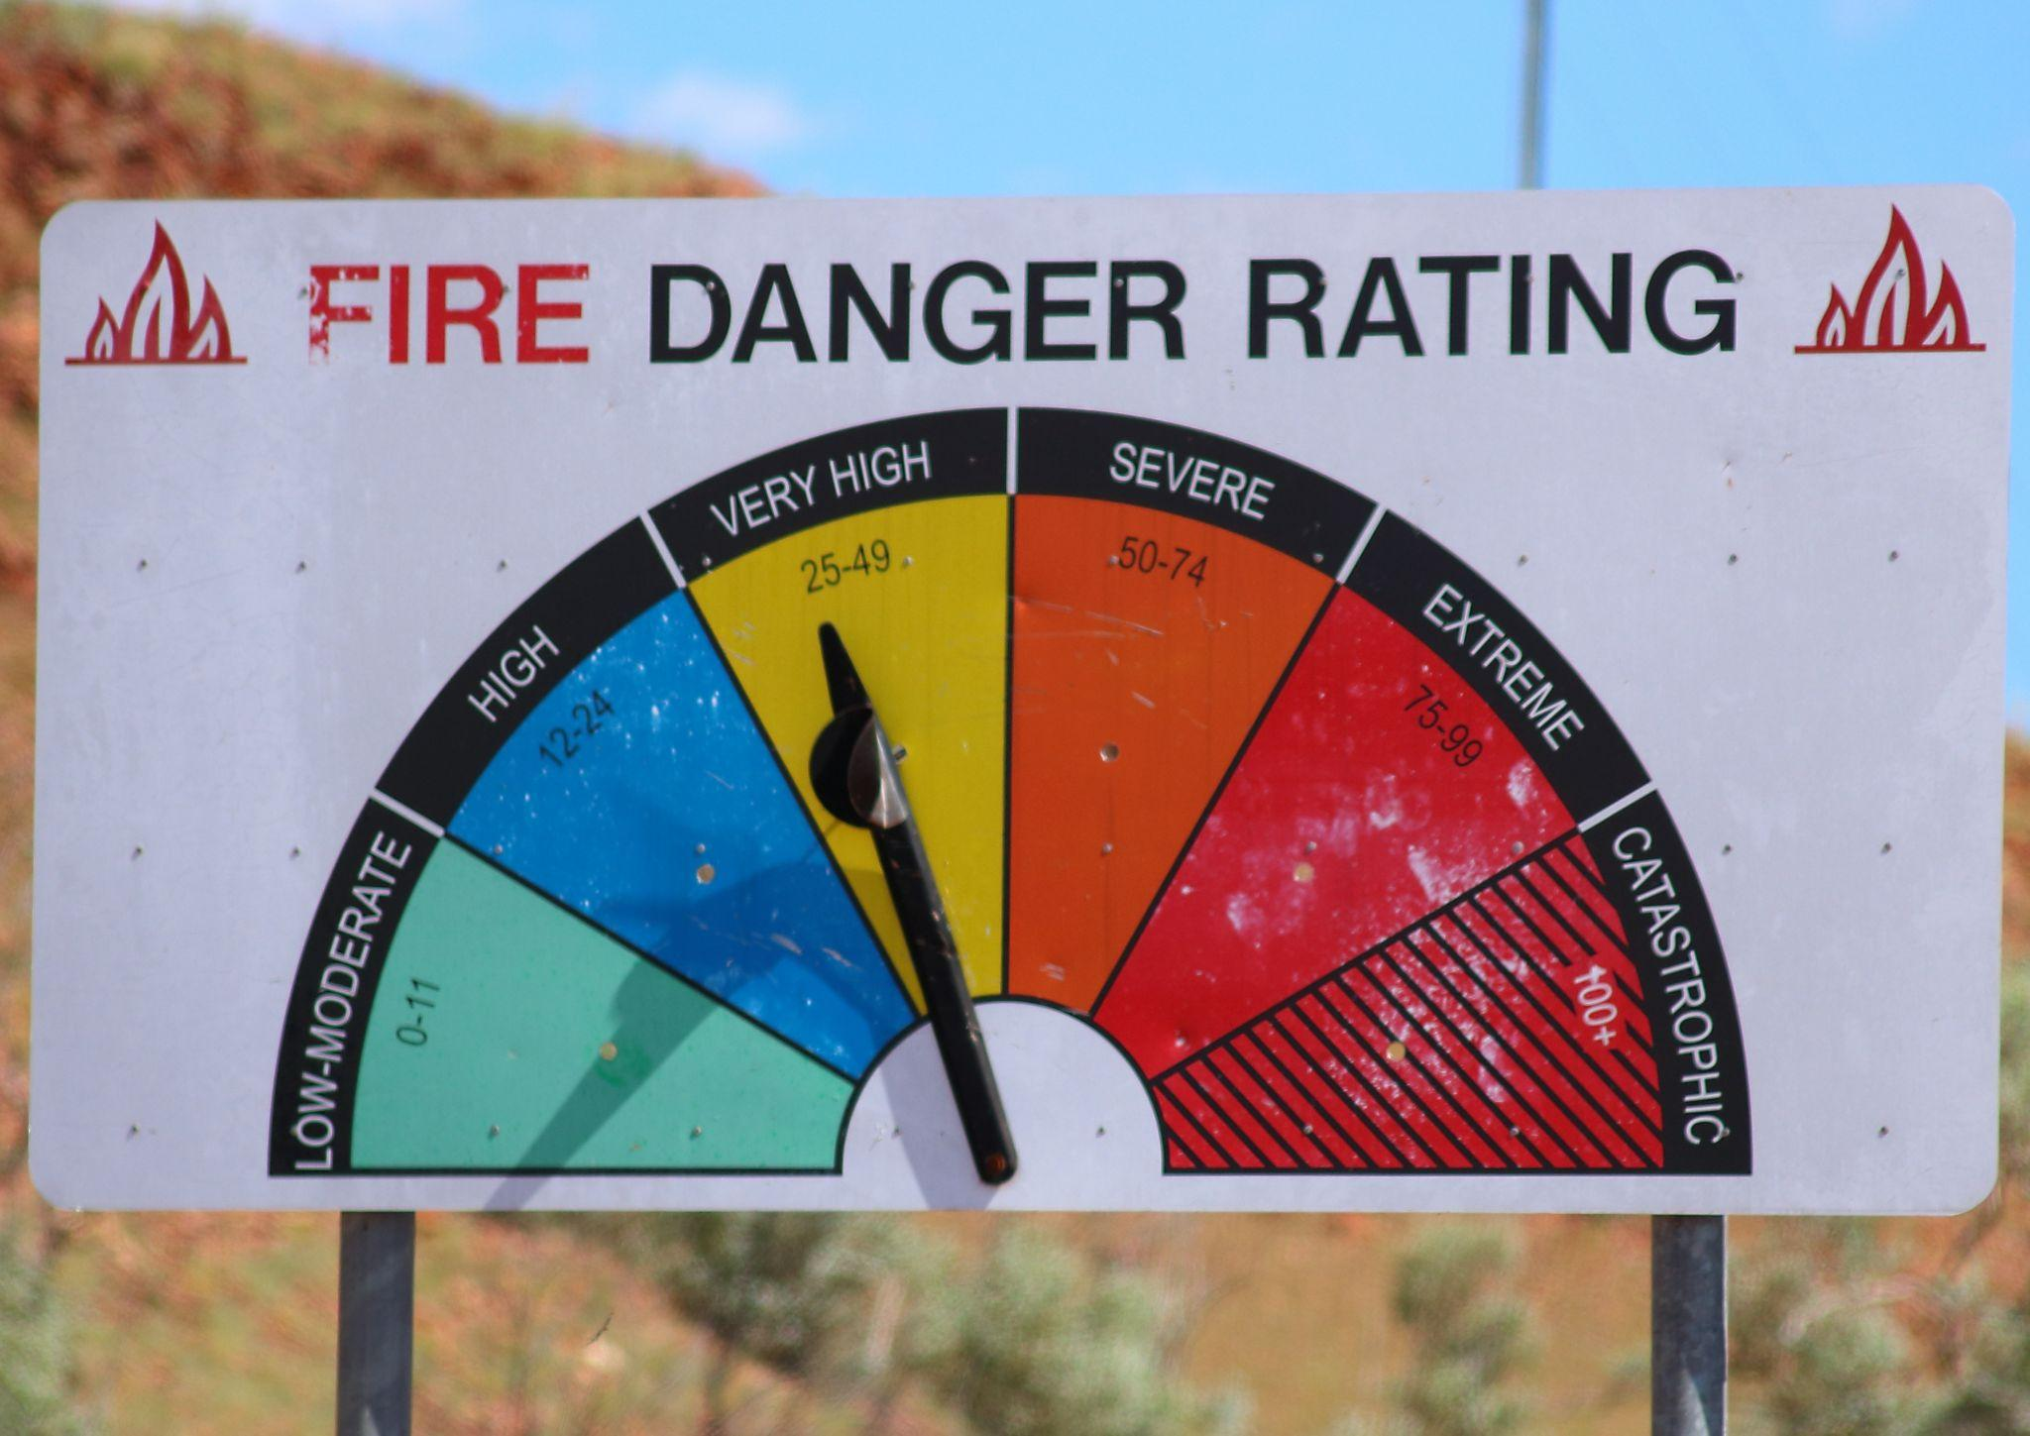

- Preparing for a Wildfire - Version 2

Caption:
Does your business have a wildfire preparedness plan?
CNA provides tips and resources to help protect your people and property, including:
- Personal and property protection best practices
- Business continuity planning
- Emergency planning for employees

Visit CNA’s Wildfire Resource Center:

Link: https://www.cna.com/wildfire-resource-center?utm_source=toolkit&utm_medium=social&utm_campaign=nap-wildfire-2026&utm_content=prepare-post-2

Questions? Reach out anytime.

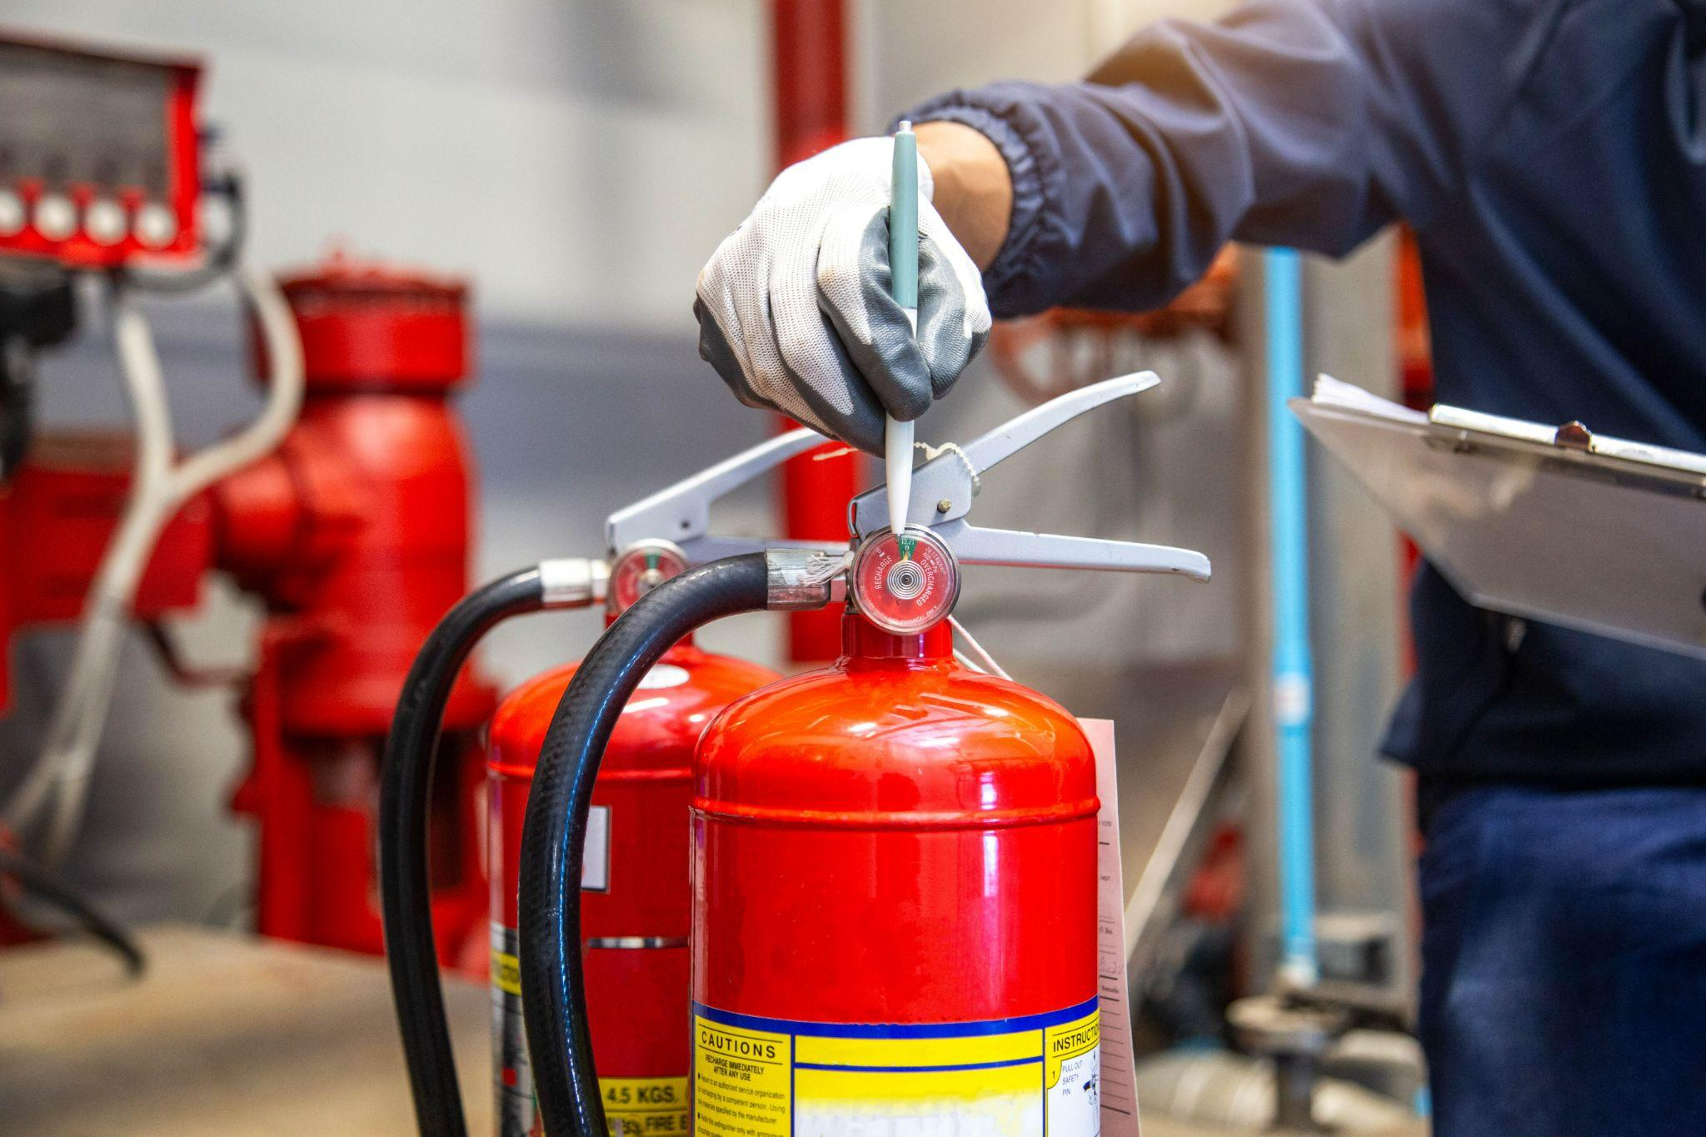

- How to Respond During

Caption:
To clients affected by the ongoing wildfires: we’re here to support you.
As conditions evolve, our team is available to answer questions, share risk mitigation strategies and advise on next steps.

CNA provides tips and resources to help you protect your people and property.

Learn more here: LINK: https://www.cna.com/wildfire-resource-center?utm_source=toolkit&utm_medium=social&utm_campaign=nap-wildfire-2026&utm_content=during-event

Quick tips from CNA include:
- Monitoring live updates
- Clearing window areas
- Closing every opening
- Packing vital records
- Moving vehicles

Stay safe.

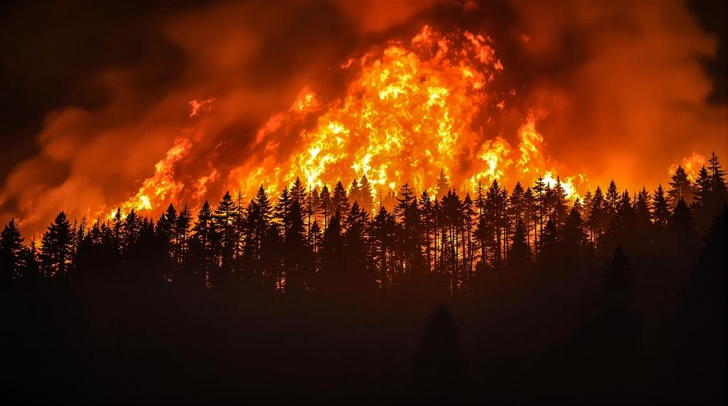

- How to Respond After

Caption:
As your business looks to return to normal operations following a wildfire, there are several important steps to take now.

- Photograph and video all damage
- Establish temporary operations or remote workspaces
- Hire professionals to check and restore utilities
- Clean ventilation and utility lines

Find more recovery tips and resources at CNA’s Wildfire Resource Center:
LINK: https://www.cna.com/wildfire-resource-center?utm_source=toolkit&utm_medium=social&utm_campaign=nap-wildfire-2026&utm_content=after-event

Whether your damage is minor or major, I’m here to support you every step of the way.

