Flood: Email and Social Media Toolkit

Brokers and Agents: Customize the copy below to send emails directly to your clients. You can also add your own messages or notes to the templates before sending. Please do not modify the hyperlinks provided on each template.

Email Copy to Insureds

Preparation Phase (before the flood) – copy and paste the below into a new email on your platform of choice.

Subject: Flood Preparedness Starts Before the Water Rises

Dear [Client Name],
Floods can occur with little warning and have lasting impacts on your property, operations and workforce.
Taking steps to prepare before flooding occurs can help reduce disruption, protect your assets, and support business continuity.
Explore resources and insights from CNA to help your organization prepare for, respond to and recover from a flooding event: CNA’s Flood Resource Center

If you’d like help reviewing your current preparedness plan or have questions about your coverage, please don’t hesitate to reach out. I’m here to support you every step of the way.

Stay safe,

[Your Name]
[Your Contact Information]

Respond/Recover Phases (during and after the flood) - copy and paste the below into a new email on your platform of choice.

Subject: Help Reduce Flood-Related Business Disruptions

Dear [Client Name],

Whether flooding is imminent or already impacting your operations, having a clear response strategy can help you protect people, stabilize critical functions, and make informed decisions during a rapidly changing situation. The steps you take now can help minimize disruption and support a more efficient recovery.

Once conditions are safe, it’s time to assess the impact, document losses, and activate your recovery plans to help restore operations.

CNA’s Flood Resource Center offers immediate flood response guidance and recovery tips to help you minimize disruptions and protect your business.

To report a claim, contact CNA’s Catastrophe Operations team:

- 877-CNA-ASAP (Option 2)
- lossreport@cnaasap.com

Stay safe and ready,

[Your Name]
[Your Contact Information]

Social Media Copy and Images

Copy and paste the below copy into a new post on your social media platform of choice. Pair with the suggested image below by right-clicking, downloading, then uploading the image to the new post. Please do not modify the highlighted hyperlinks given on each post caption. Links will shorten automatically when posted to LinkedIn.

Flood Preparation Post:
Flooding can impact businesses with little warning, making preparedness essential. It’s important to review plans, assess vulnerabilities, and take steps to help protect your people, property, and operations.
Visit CNA’s Flood Resource Center for tools and insights designed to help you stay ready before a flood occurs: https://www.cna.com/flood-resource-center?utm_source=toolkit&utm_medium=social&utm_campaign=nap-flood-2026&utm_content=prepare

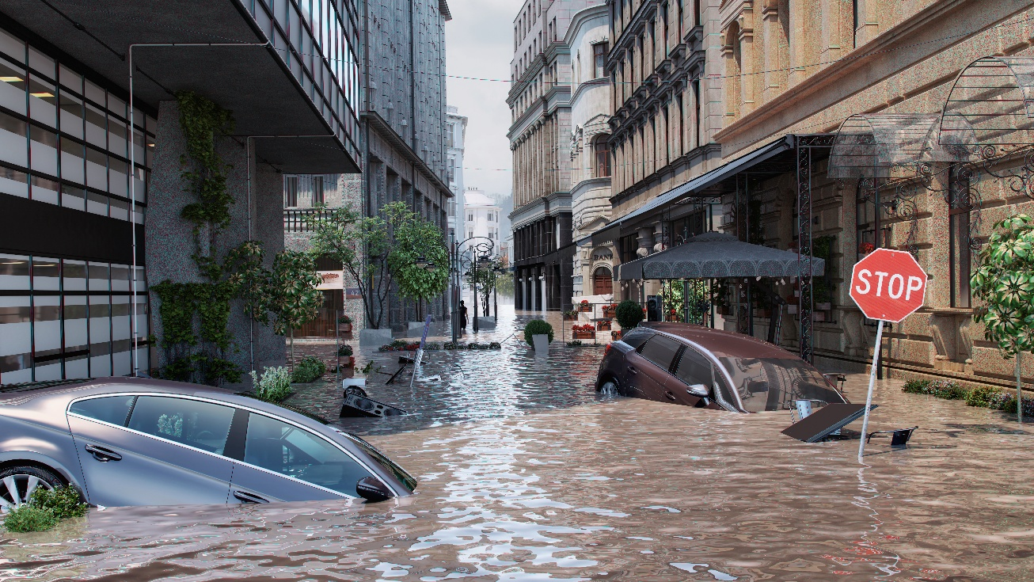

Flood Response Post:

The effects of flooding can continue long after the water recedes. As recovery efforts begin, having the right information and resources can make a meaningful difference in helping your organization recover and get back to business.
Whether you're assessing damage, coordinating cleanup activities or helping employees navigate the aftermath, we're here to support your recovery.

Visit CNA’s Flood Resource Center for step-by-step guidance and support through the recovery process: https://www.cna.com/flood-resource-center?utm_source=toolkit&utm_medium=social&utm_campaign=nap-flood-2026&utm_content=respond

