Severe Convective Storms: Email and Social Media Toolkit

Brokers and Agents: Customize the copy below to send emails to your clients. You can also add your own messages or notes to the templates before sending.

Email Copy to Insureds
Preparation Phase (before the storm) – copy and paste the below into a new email on your platform of choice.

Subject: Protect Your Business with CNA’s Severe Convective Storm Resources Dear [Client Name],
Severe convective storms (SCS) – including hail, tornadoes and damaging winds – can pose significant risk to your business and property.

The best way to protect your employees, property and business this SCS season is to prepare before storms develop.

Refer to these resources and insights throughout the season:

Severe Convective Storms Resource page

If you’d like help reviewing your current preparedness plan or have questions about your coverage, please don’t hesitate to reach out. I’m here to support you every step of the way.
Stay safe and prepared, [Your Name]
[Your Contact Information]

Disclaimer:
“CNA” is a registered trademark of CNA Financial Corporation. Certain CNA Financial Corporation subsidiaries use the “CNA” trademark in connection with insurance underwriting and claims activities. Copyright © 2026 CNA. All rights reserved.

Respond/Recover Phases (during and after the storm) - copy and paste the below into a new email on your platform of choice.

Subject: Severe Storm Season Alert: Hail, Wind, Flooding & Recovery Support for Your Business

Dear [Client Name],

I want to ensure you're fully supported as the severe storm season brings increased risks to our community. These events can significantly impact your operations, but you don’t have to face them alone.

CNA’s Severe Convective Storms Resource page has immediate storm response and recovery tips to help you minimize disruption and protect your business.

Need to Report a Claim?

CNA’s Catastrophe Operations Center is fully staffed and ready to assist:

General Claims:
- Phone: 877-CNA-ASAP (877-262-2727), Option 2
- Fax: 800-953-7389
- Email: lossreport@cnaasap.com

Small Business Claims:
- Phone: 833-FNOL-CNA (833-366-5262)
- Fax: 877-291-2019
- Email: ReportClaim@FNOLCNA.com

Stay safe and prepared, [Your Name]
[Your Contact Information]

Social Media Copy and Images

Preparation Phase (before the storm) post copy – copy and paste the below into a new post on your social media platform of choice. Pair with one of the corresponding images of your choice by right-clicking, downloading, then uploading to the new post.

As severe storm season continues, preparation is key to protecting people, property and operations. Now is the time to take proactive steps and use available resources to stay ready at every stage of a potential storm.

- Explore essential tools and insights to help you weather the storm with confidence.

Use this link when posting: https://www.cna.com/severe-convective-storms?utm_source=toolkit&utm_medium=social&utm_campaign=nap-toolkit-scs-2026&utm_content=prep

Respond/Recover Phases (during and after the storm) copy – copy and paste the below into a new post on your social media platform of choice. Pair with one of the corresponding images of your choice by right -clicking, downloading, then uploading to the new post.

As our communities begin to recover from the impacts of recent severe storms, having the right resources in place is critical.

Whether you're managing a business, supporting a team or helping others clean up and rebuild, timely guidance can make all the difference.

Visit CNA’s Claims Center for step-by-step guidance and support through the recovery process.

Use this link when posting: https://www.cna.com/claims-center?utm_source=toolkit&utm_medium=social&utm_campaign=nap-toolkit-scs-2026&utm_content=respond

Social Media Images
Right-click on your image of choice , select “Save as Picture”, then upload to your post

Business buildings with flooded streets
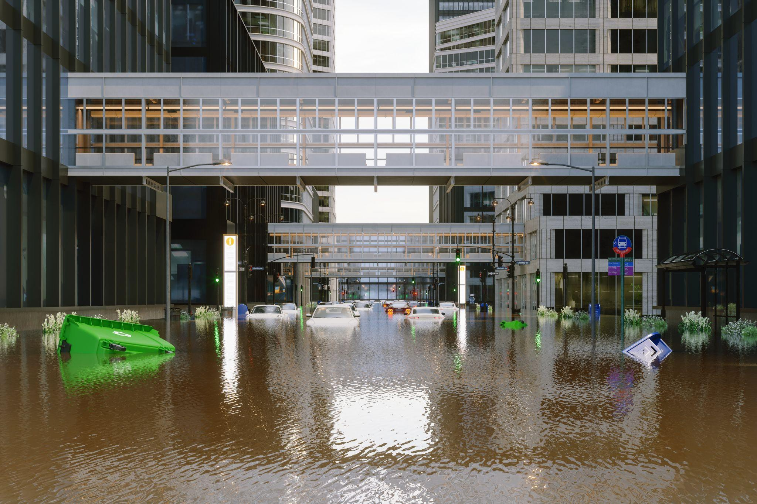

Boarding Up Business

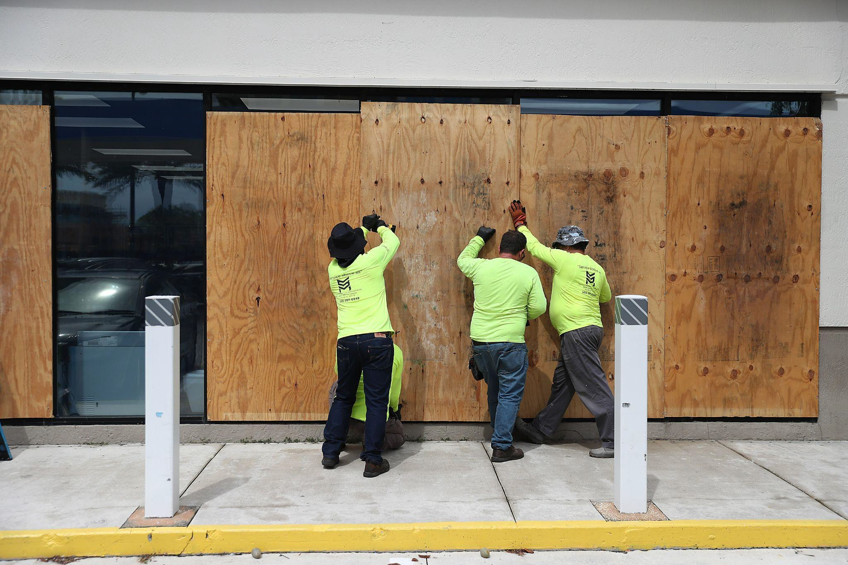

Crews search through rubble


Debris of destroyed buildings
