**Hurricane Season Email and Social Media Toolkit**

**Email Copy to Insureds**

1. **Coastal Insureds – Preparation Phase (before the storm)**  – *copy and paste the below into a new email on your platform of choice.*

Subject: Hurricane Resources to Help Protect Your Business

Dear [Client Name],

Tropical storms and hurricanes can bring powerful winds, storm surge, flooding, and extended power outages, all of which can significantly disrupt your business operations.

To help you prepare for storms and stay ready, here are some resources and insights to reference throughout the season:

* [**Storm Preparedness & Recovery Tools**](https://www.cna.com/hurricanes-and-tropical-storms?utm_source=oft&utm_medium=email&utm_campaign=rc-hurricane-2025&utm_content=agent-insured-coastal-prep)**:** Access planning guides, response strategies, and claims information on CNA’s [Hurricane and Tropical Storms Resource page](https://www.cna.com/hurricanes-and-tropical-storms?utm_source=oft&utm_medium=email&utm_campaign=rc-hurricane-2025&utm_content=agent-insured-coastal-prep).
* Use the [**Hurricane Season Preparedness Checklist**](https://www.cna.com/sites/default/files/assets/48ec1a28-9471-436c-b457-64d55d4cbe7e/RC-Hurricane-Preparedness-Checklist.pdf?fid) to help develop your action plan for storms.
* CNA’s [**Resilience Checklist for Approaching Hurricanes**](https://www.cna.com/sites/default/files/assets/95932a62-0963-4c73-bc31-e0f6c6774ab8/Resilience-Checklist-for-Approaching-Hurricanes.pdf?fid) can help you prepare when a storm is forecasted for your area.

If you’d like help reviewing your current preparedness plan or have questions about your coverage, please don’t hesitate to reach out. I’m here to support you every step of the way.

Stay safe and prepared,

[Your Name]

[Your Contact Information]

1. **Inland Insureds – Preparation Phase (before the storm)** *- copy and paste the below into a new email on your platform of choice.*

Subject: Preparing for Inland Effects of Hurricane Season

Dear [Client Name],

Even if you're located far from the coast, tropical storms and hurricanes can still pose serious risks to your business. Inland flooding, high winds, and extended power outages can all disrupt operations and cause damage. The good news is that with the right preparation, you can significantly reduce the impact.

To help you stay ready, here are some resources and insights to reference throughout the season:

* [**Storm Preparedness & Recovery Tools**](https://www.cna.com/hurricanes-and-tropical-storms?utm_source=oft&utm_medium=email&utm_campaign=rc-hurricane-2025&utm_content=agent-insured-inland-prep)**:** Access planning guides, response strategies, and claims information on CNA’s [Hurricane and Tropical Storms Resource page](https://www.cna.com/hurricanes-and-tropical-storms?utm_source=oft&utm_medium=email&utm_campaign=rc-hurricane-2025&utm_content=agent-insured-inland-prep).
* Use the [**Hurricane Season Preparedness Checklist**](https://www.cna.com/sites/default/files/assets/48ec1a28-9471-436c-b457-64d55d4cbe7e/RC-Hurricane-Preparedness-Checklist.pdf?fid) to help develop your action plan for storms.
* CNA's [**Resilience Checklist for Approaching Hurricanes**](https://www.cna.com/sites/default/files/assets/95932a62-0963-4c73-bc31-e0f6c6774ab8/Resilience-Checklist-for-Approaching-Hurricanes.pdf?fid) can help you prepare when a storm is forecasted for your area.

If you’d like help reviewing your current preparedness plan or have questions about your coverage, please don’t hesitate to reach out. I’m here to support you every step of the way.

Stay safe and prepared,

[Your Name]

[Your Contact Information]

1. **Coastal Insureds – Respond/Recover Phases (during and after the storm)**  - *copy and paste the below into a new email on your platform of choice.*

Subject: Hurricane Season Alert: Flooding & Recovery Support for Your Business

Dear [Client Name],

I want to ensure you're fully supported as hurricane season brings increased risks to our coastal communities. These events can significantly impact your operations, but you don’t have to face them alone.

To help you stay prepared and recover quickly, here are some key resources and steps you can take:

[**Storm Preparation & Recovery Tools**](https://www.cna.com/hurricanes-and-tropical-storms?utm_source=oft&utm_medium=email&utm_campaign=rc-hurricane-2025&utm_content=agent-insured-coastal-rec)

CNA’s [Hurricanes and Tropical Storms Resource page](https://www.cna.com/hurricanes-and-tropical-storms?utm_source=oft&utm_medium=email&utm_campaign=rc-hurricane-2025&utm_content=agent-insured-coastal-rec) has immediate storm response and recovery tips to help you minimize disruption and protect your business.

**Need to Report a Claim?**

CNA’s Catastrophe Operations Center is fully staffed and ready to assist:

[**General Claims**](https://www.cna.com/claims-center?utm_source=oft&utm_medium=email&utm_campaign=rc-hurricane-2025&utm_content=agent-insured-coastal-rec)**:**

• Phone: 877-CNA-ASAP (877-262-2727), Option 2

• Fax: 800-953-7389

• Email: lossreport@cnaasap.com

[**Small Business Claims:**](https://www.fnolcna.com/Landing.aspx)

• Phone: 833-FNOL-CNA (833-366-5262)

• Fax: 877-291-2019

• Email: ReportClaim@FNOLCNA.com

If you have any questions, need help navigating these resources, or want to review your coverage, please don’t hesitate to reach out to me directly. I’m here to support you before, during, and after the storm.

Stay safe and prepared,

[Your Name]

[Your Contact Information]

1. **Inland Insureds – Respond/Recover Phases (during and after the storm)**  - *copy and paste the below into a new email on your platform of choice.*

Subject: Hurricane Season Alert: Flooding & Recovery Support for Your Business

Dear [Client Name],

I want to make sure you're fully supported as hurricanes and related events bring risks to businesses. While coastal areas often face the brunt of the storm, inland regions are not immune to the effects of heavy rainfall, flash flooding, and strong winds that can disrupt operations and cause significant damage.

To help you stay ready and recover quickly, here are some important resources:

[**Storm Preparation & Recovery Tools**](https://www.cna.com/hurricanes-and-tropical-storms?utm_source=oft&utm_medium=email&utm_campaign=rc-hurricane-2025&utm_content=agent-insured-inland-rec)

CNA’s [Hurricanes and Tropical Storms Resource page](https://www.cna.com/hurricanes-and-tropical-storms?utm_source=oft&utm_medium=email&utm_campaign=rc-hurricane-2025&utm_content=agent-insured-inland-rec) has immediate storm response and recovery tips to help businesses like yours minimize downtime and protect assets.

**Need to Report a Claim?**

CNA’s Catastrophe Operations Center is fully operational and ready to assist:

[**General Claims:**](https://www.cna.com/claims-center?utm_source=oft&utm_medium=email&utm_campaign=rc-hurricane-2025&utm_content=agent-insured-inland-rec)

• Phone: 877-CNA-ASAP (877-262-2727), Option 2

• Fax: 800-953-7389

• Email: lossreport@cnaasap.com

[**Small Business Claims:**](https://www.fnolcna.com/Landing.aspx)

• Phone: 833-FNOL-CNA (833-366-5262)

• Fax: 877-291-2019

• Email: ReportClaim@FNOLCNA.com

If you have any questions, need help navigating these resources, or would like to review your current coverage, please don’t hesitate to reach out. I’m here to support you every step of the way.

Stay safe and prepared,

[Your Name]

[Your Contact Information]

**Social Media Copy and Images**

1. **Preparation Phase (before the storm) copy**– *copy and paste the below into a new post on your social media platform of choice. Pair with one of the corresponding images of your choice by right clicking, downloading, then uploading to the new post.*

As hurricane season continues, preparation is key to protecting people, property and operations. Now is the time to take proactive steps with valuable resources available to help you stay ready at every stage of a potential storm.

[**Explore essential hurricane preparedness tools and insights**](https://www.cna.com/hurricanes-and-tropical-storms?utm_source=linkedin&utm_medium=social&utm_campaign=rc-hurricane-2025&utm_content=agent) to help you weather the storm with confidence.

1. **Respond/Recover Phases (during and after the storm) copy** – *copy and paste the below into a new post on your social media platform of choice. Pair with one of the corresponding images of your choice by right clicking, downloading, then uploading to the new post.*

As communities begin to recover from the impacts of recent storms, having the right resources in place is critical.

Whether you're managing a business, supporting a team or helping others rebuild, timely guidance can make all the difference. [**Visit CNA’s Claims Center**](https://www.cna.com/claims-center?utm_source=linkedin&utm_medium=social&utm_campaign=rc-hurricane-2025&utm_content=agent) for step-by-step guidance and support through the recovery process.

**Social images** – *right click on your image of choice, select “Save as Picture”, then upload to your post.*

Starting a Checklist

Flooded Streets

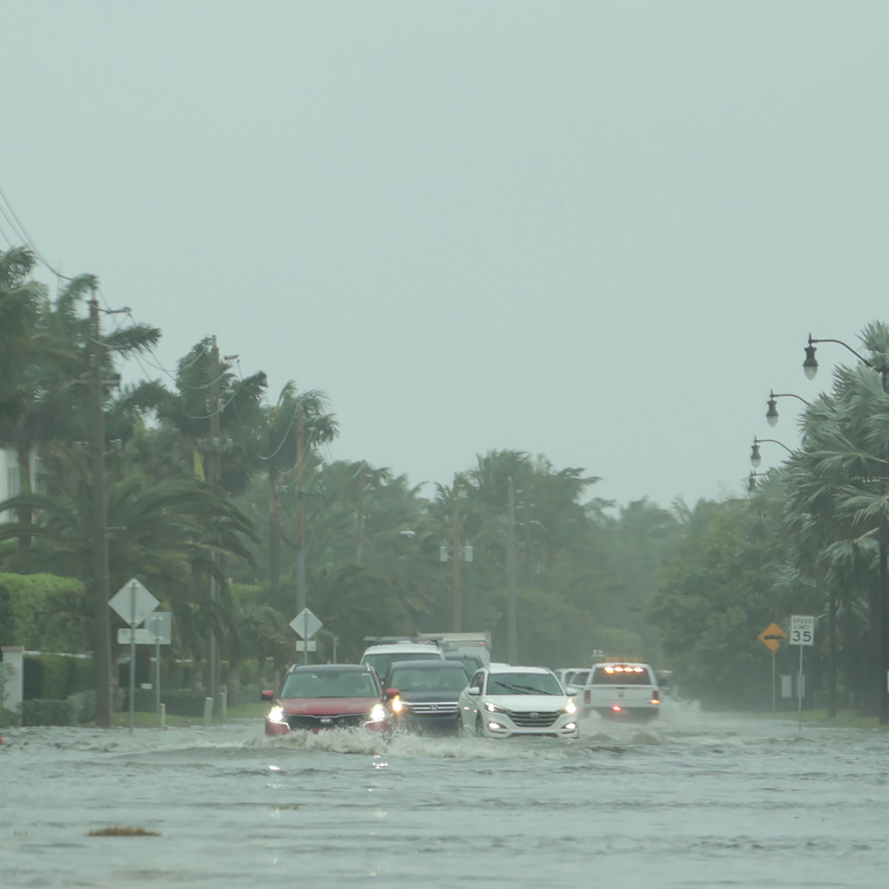

Boarding Up Businesses

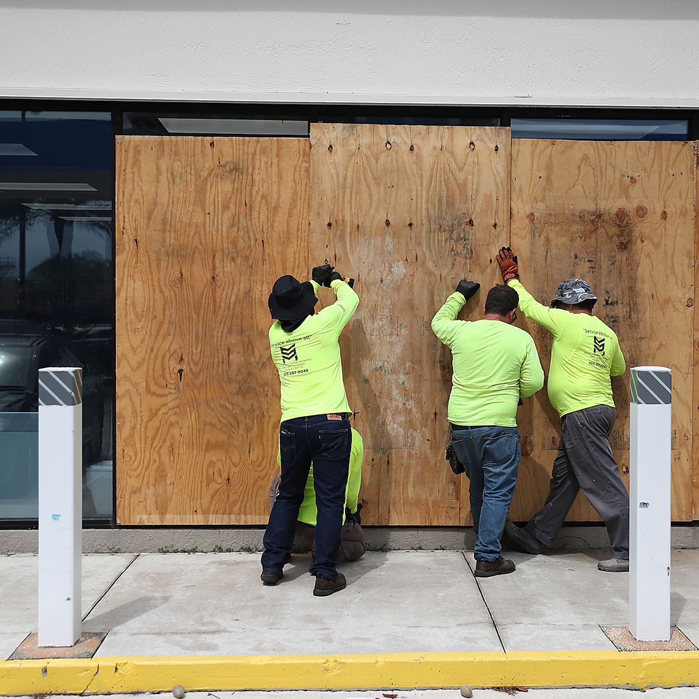

After the Storm

