Winter Storms: Email and Social Media Toolkit
Brokers and Agents: Customize the copy below to send emails directly to your clients. You can also add your own messages or notes to the templates before sending. Please do not modify the hyperlinks provided on each template.

Email Copy to Insureds
Preparation Phase (before the winter storm) - copy and paste the below into a new email on your platform of choice
Subject: Get Your Business Winter-Ready with Resources from CNA
Dear [Client Name],
Winter storms can have lasting effects on your property, operations and workforce.
Taking steps to prepare before severe winter weather arrives can help reduce disruption, protect your assets and support business continuity.
Explore resources and insights from CNA to help your organization prepare for, respond to and recover from a winter storm: CNA’s Winter Storm Resource Center
If you’d like help reviewing your current preparedness plan or have questions about your coverage, please don’t hesitate to reach out. I’m here to support you every step of the way.

Stay safe,

[Your Name]
[Your Contact Information]

Respond/Recover Phases (during and after the storm) - copy and paste the below into a new email on your platform of choice.
Subject: Help Reduce Winter Storm Disruptions to Your Business
Dear [Client Name],
Winter storms can disrupt operations, threaten property and create challenges for employees.
Whether a winter storm is approaching or already affecting your operations, having a clear response strategy can help you protect people, stabilize critical functions and make informed decisions as conditions change. The steps you take now can help minimize disruption and support a more efficient recovery.
CNA’s Winter Storm Resource Center offers immediate winter storm response guidance, recovery tips and more to help you minimize disruptions and protect your business.

To report a claim, contact CNA's Catastrophe Operations team:
•877-CNA-ASAP (Option 2)
•lossreport@cnaasap.com

Stay safe and ready,
[Your Name]
[Your Contact Information]

Social Media Copy and Images
Copy and paste the below copy into a new post on your social media platform of choice. Pair with the suggested image below by right-clicking, downloading, then uploading the image to the new post. Please do not modify the highlighted hyperlinks given on each post caption. Links will shorten automatically when posted to LinkedIn.

Winter Storm Preparation Post
Caption:
Winter storms can disrupt operations, strain resources and create safety concerns. Preparing ahead of time can help businesses stay ready for changing conditions and respond with confidence.
Visit CNA’s Winter Storm Resource Center for tools and insights designed to help you stay ready before severe winter weather arrives.

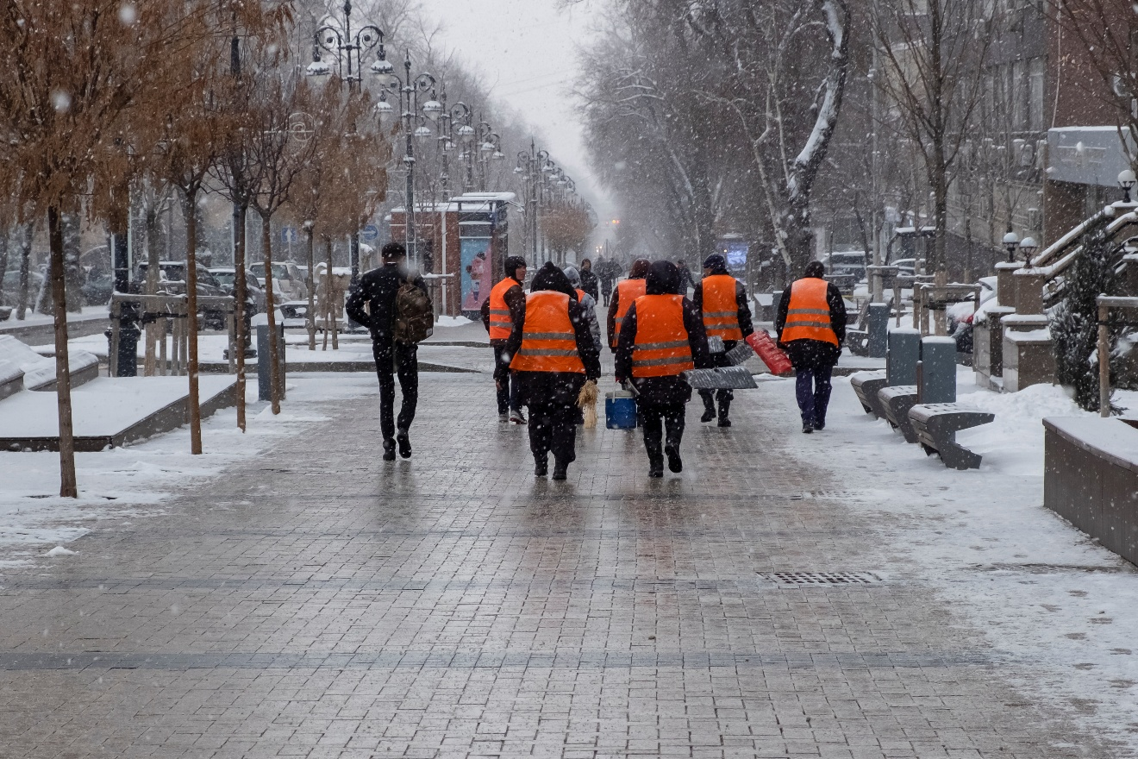

Winter Storm Response Post
Caption:
The impacts of a winter storm can continue long after the snow, ice and freezing temperatures subside. During the event and throughout the recovery process, having access to the right resources can help support informed decisions.
Whether you're managing operational disruptions, assessing damage or coordinating recovery efforts, we're here to support your recovery.
Visit CNA’s Winter Storm Resource Center for step-by-step guidance and support through the recovery process.

